======================================================================

**Name : Atharva Paliwal**

**Roll No : 6B 40**

**Course Name : Software Engineering Lab**

**Course Code : CSP357**

**Experiment No :** 06

**Aim :** To create a Component and Deployment Diagram to

represent the dynamic view (behavior) of the

system.

**Problem Statement :** Create a Component and Deployment diagram using

Star UML application for **“Courier Management System”**

**Date of Experiment:** 28-March-2021

======================================================================

COMPONENT DIAGRAM

======================================================================

Component diagrams are different in terms of nature and behavior. Component diagrams are used to model the physical aspects of a system. Now the question is, what are these physical aspects? Physical aspects are the elements such as executables, libraries, files, documents, etc. which reside in a node.

Component diagrams are used to visualize the organization and relationships among components in a system. These diagrams are also used to make executable systems.

## Purpose of Component Diagrams

Component diagram is a special kind of diagram in UML. The purpose is also different from all other diagrams discussed so far. It does not describe the functionality of the system but it describes the components used to make those functionalities.

Thus from that point of view, component diagrams are used to visualize the physical components in a system. These components are libraries, packages, files, etc.

Component diagrams can also be described as a static implementation view of a system. Static implementation represents the organization of the components at a particular moment.

A single component diagram cannot represent the entire system but a collection of diagrams is used to represent the whole.

The purpose of the component diagram can be summarized as −

* Visualize the components of a system.
* Construct executables by using forward and reverse engineering.
* Describe the organization and relationships of the components.

======================================================================

DEPLOYMENT DIAGRAM

======================================================================

Deployment diagrams are used to visualize the topology of the physical components of a system, where the software components are deployed.

Deployment diagrams are used to describe the static deployment view of a system. Deployment diagrams consist of nodes and their relationships.

**Purpose of Deployment Diagrams**

The term Deployment itself describes the purpose of the diagram. Deployment diagrams are used for describing the hardware components, where software components are deployed. Component diagrams and deployment diagrams are closely related.

Component diagrams are used to describe the components and deployment diagrams shows how they are deployed in hardware.

UML is mainly designed to focus on the software artifacts of a system. However, these two diagrams are special diagrams used to focus on software and hardware components.

Most of the UML diagrams are used to handle logical components but deployment diagrams are made to focus on the hardware topology of a system. Deployment diagrams are used by the system engineers.

The purpose of deployment diagrams can be described as −

* Visualize the hardware topology of a system.
* Describe the hardware components used to deploy software components.
* Describe the runtime processing nodes.

.

*************************************************************************************

DEPLOYMENT DIAGRAM

*************************************************************************************

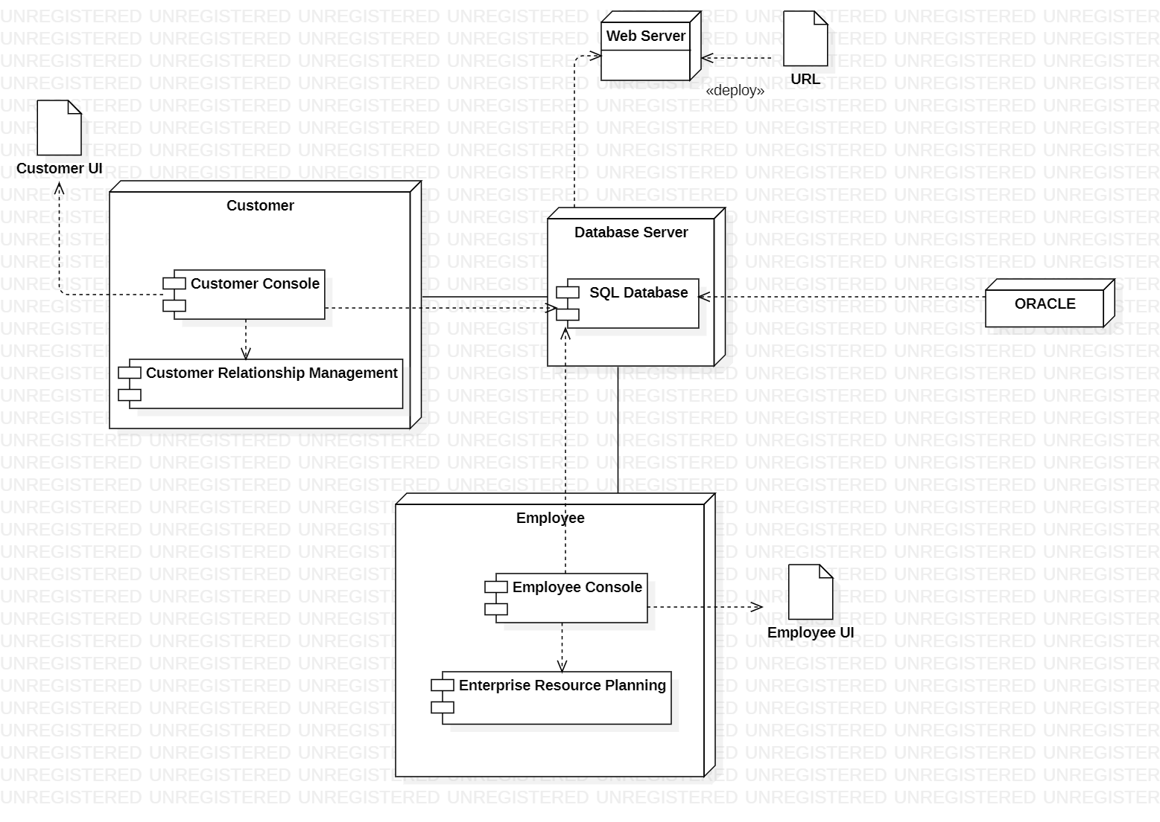

*************************************************************************************

COMPONENT DIAGRAM

*************************************************************************************

